THE ORGANS OF ST. MARY with ALL SOULS, KILBURN 2017
Compiled by Alan Saggerson (Director of Music/Organist) with acknowledgment to Ian Bell (Consultant reporting on the Bishop refurbishment works completed in 2011 and coincidentally on the Downing organ in 2002 before translation to St. Mary’s in 2014)
THE VICTORIAN “BISHOP” CHANCEL ORGAN
1862; 1892; 1951; 2011
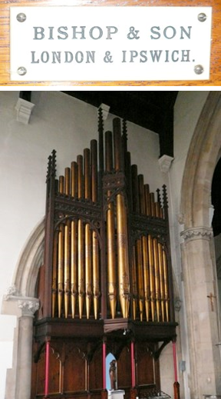
The organ appears to have been commissioned and installed in time for the consecration of the new church in 1862. It was built by a firm that had been founded by one of the most respected organ builders of the period, J.C.Bishop, who had died in 1854, but who shortly before his death had taken into partnership one of his senior workmen, John Starr. To share the unaccustomed burden Starr, in turn, co-opted another faithful employee, William Richardson, to share the running of the company — which from 1857 until 1861 became known as Bishop, Starr and Richardson. In 1861 Richardson retired and his name was dropped from the notepaper, but the 1862 Kilburn organ perpetuates the partnership with several cast iron bellows weights impressed with the three initials, B S & R.
It must be said that by the time of J.C.Bishop’s death his earlier flair and innovation had faded somewhat — he was after all over 70 — and his successors were for some years happy to follow more or less in the style he had established. Fortunately this included his having already embraced the relatively novel ‘German System’ of organ design, with a proper pedal keyboard, and manual compasses beginning at C rather than extending lower in 18th century fashion. It would appear that the Kilburn organ benefited from this, having C-compass Great and Choir sections, though with a Swell that still omitted the lowest octave.
This was by any standards a substantial example of the new partnership’s work, reflecting the status and social standing of the church and its congregation. Much of the pipework and other material that it contained was absorbed into an even more ambitious instrument, built again by the Bishop firm, in two successive operations in 1886 and 1892. It would seem that the short-compass Swell survived the first session of work, but was brought up to date at the second. The outcome of this was in all essentials the instrument that survives today, the 40 stops being noted alongside. The mechanism had become tubular-pneumatic — operated by wind-pressure — and remained in use for some 60 years thereafter.
The organ seems to have been left in peace until after WWII, by which time it must have been decidedly tired. It briefly left the care of Bishop & Son in the late 1940s when a scheme for modernisation was put forward by the North London firm of Hill, Norman & Beard, and accepted by the church. This was then cancelled however, and in 1951 the instrument returned to the Bishop fold for what on paper appears to have been a conservative and respectful rebuild. The mechanism was converted to work electrically, and a new detached console was provided, made to the compact stop-key design popular at the time. The tonal scheme remained on paper almost unaltered apart from — unusually — the removal of three stops, leaving the space on the soundboards empty. It is clear however that there was some revoicing, particularly of the reed stops. Thereafter, apart from the addition of a second-hand Pedal reed, things remained unchanged until very recently.
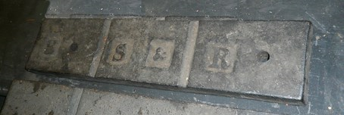
Bishop, Starr & Richardson weight.
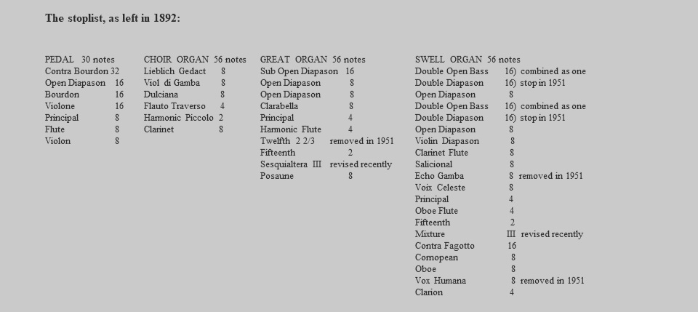
Recently, refurbishment and restoration work has been undertaken by William Johnson, originally of the Cambridge firm E.J.Johnson, but for some 15 years annexed loosely to the J.W.Walker & Sons conglomerate in Brandon, Suffolk. This work was pronounced as complete late in 2011, though in fact it did leave some areas untouched. It should be stated immediately that much of this recent work has been carried out to an excellent standard, and completed in a fully professional fashion that is as good as anything that one would find anywhere, and therefore beyond reproach. Where there are shortcomings amongst this work (noted in the paragraphs that follow) it is largely in the tidiness and finish of some aspects, and therefore only cosmetic rather than contributing to any malfunctions. Intermittent problems can be attributed, at least in part, to the unavoidable vulnerability of any Victorian organ to cyclic oscillation in temperature and relative humidity, affecting in particular some moving parts of the soundboards. Finally a small amount of the 1951 work has simply not been refurbished, including some aspects which have prominently given trouble recently. I have not seen the contract paperwork or other undertakings offered by Mr Johnson, nor his remarks at the conclusion of the work or since, so can only make observations upon the state of things as I found them.
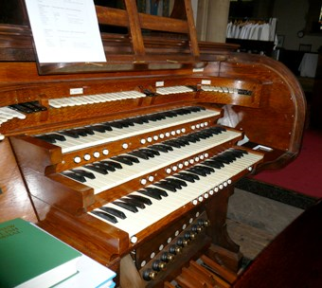
The console was new in 1951. Though not elaborate in design or materials this was, and remains, a sturdy and professionally made piece of equipment — albeit in a style that is no longer popular, but is convenient to the circumstances here. Recent restoration has been in some respects selective in its extent but this may simply reflect the funds available and commitments that were made accordingly. The playing surfaces of the manual keyboards remain those of 1951, being of celluloid and blackwood. Though the naturals are somewhat yellowed they show little other surface wear. There are some slightly irregular gaps and a little side-play
arising from a degree of wear to the bushings, but nothing worrying. The key-touch is acceptably regular and clean. The recently added American-style thumb pistons are spaced in accordance with the modern expectation and custom.
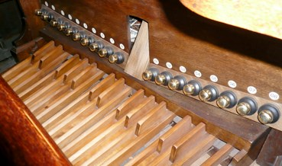
The pedal keyboard, again new in 1951, has certainly been overhauled and refelted, but the surfaces have not been refaced — merely scraped and repolished — and there is noticeable wearing-down of both the sharp and natural keys in the most heavily used range. This is not hazardous and would not be a cause for comment except in this context of a newly over-hauled instrument.
The position of the pedal keys in relation to the manuals is close to the modern standard — closer to the German standard than the British one, but not unusual in that. The swell-pedal, which appears to have been recently renewed, opens to too wide an angle to be entirely comfortable, and is if anything a small amount further from the player than is usual. This could easily be modified.
The toe pistons are curious. Their position is the reverse of the usual expectation, with the generals to the right and the Pedal to the left, and — very oddly — the reversible pistons to the couplers at the extreme left-hand end, rather than divided either side of the swell pedal as is normal. Furthermore because they are mounted on the knee panel rather than curved to follow the pedals, the pistons at each extreme are awkward to reach, and the whole knee panel rattles noisily when any of the toe pistons are pressed. This whole aspect deserves further attention; silencing the rattles should be relatively easy, albeit at the cost of making it more awkward to remove the knee panel when required (not a frequent requirement). Whether the non-standard order from left to right should be revised depends upon whether it is found annoying. Rewiring would be easy; moving the labels less so.
The stoptabs, of machine-engraved white plastic, are tidy enough and have been cleaned and mounted on new tab units. This has resulted in unwanted holes for the former fixing bolts at the top of each tab, though these only show when the tabs are ‘on’. The new equipment is working well. All of the other low-voltage console components have similarly been tidily renewed, and all are from respected suppliers, including the 8-level piston capture system, by A.J.&L.Taylor. This is thorough work, and fully executed, including the provision of new PVC-insulated cabling throughout.
Heard from the church the Swell box is unusually lacking in dynamic range, and inspection soon reveals why. The shutters are not fully closed when they should be, and only open a minimal amount — about a third of what would be desirable — when the swell pedal is opened. The swell shutter engine appears again to date from 1951. It cannot be dismantled for inspection whilst it is in position, but there is no outward sign of it having been releathered, and there is leakage from the primary valves suggesting that the internal leatherwork or canvas has perished. Whether, if returned to good order, it would be capable of opening the shutters fully cannot be ascertained — though there is no obvious reason why not. Most builders today would prefer to avoid that risk and replace it with one of the excellent and silent all-electric engines readily available from specialist organ building suppliers.

Wind System
The main electric blower is outside the organ chamber and was not inspected. It has recently been augmented by a smaller ‘booster’ blower, providing a higher wind-pressure to just the slider actions — presumably in an attempt to overcome the inadequacies already discussed. Even with this help the main blower is in fact not adequate to support the full demand, though (working alone) it was not possible to determine definitively whether the inadequacy was in the blower itself, or in the setting of the inlet valves of the various reservoirs (which from simply visual inspection appear fine).
The wind-pressure delivered to the pipes and mechanism is regulated by three bellows or reservoirs, the smallest of which has been restored but is disconnected and out of use. The other two are of some age, and of double-rise design. They have recently been fully and very neatly restored and are in good order. The original wooden trunking has recently been augmented in places by modern flexible ducting, or by plastic plumber’s piping, which sits rather unhappily amongst the older work but fulfils the practical needs well enough. The wind supply is in general acceptably steady, though double-rise reservoirs can often tend to introduce a degree of nervousness, which can be triggered here but is not related to the recent work.

Pipework
The pipework, as will be gathered, is almost entirely from the different stages of Messrs Bishop’s attention. It has relatively recently all been out, and apart from a little dust it is not dirty, and there is little by way of damage.
The organ’s tonal characteristics certainly reflect its period and builder in most respects. The Swell was originally, unusually mild — which can only partly be attributed to the inadequate opening of the swellbox – but such mildness was eradicated in 2012 by the provision of new shutters and hydraulic opening mechanism. The tonal regulation is generally good — and has certainly been left as tidy as one would expect from a primarily mechanism-centred operation such as has recently taken place. Only two aspects grate on the ear — the Choir Lieblich Gedact has at some time been loudened and made coarse, meaning that it coughs distractingly at the onset of speech in a manner influenced by the short-lived neo-classical fashion. Similar the two Mixture stops have at some time in the 1990s been unwisely loudened having had the compositions re-cast to make them higher in pitch, with the result that they do not blend, and sound quite out of place in this context. This is unfortunate — but can be relatively easily reversed and will be attended to after the church’s major redecoration programme in 2017.

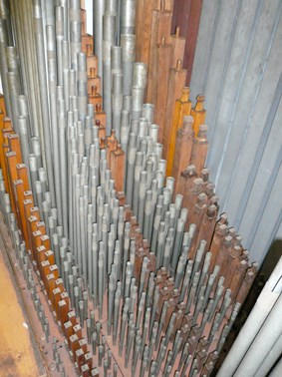

Downing College, Cambridge 1966/1982

St. Mary with All Souls Kilburn 2014
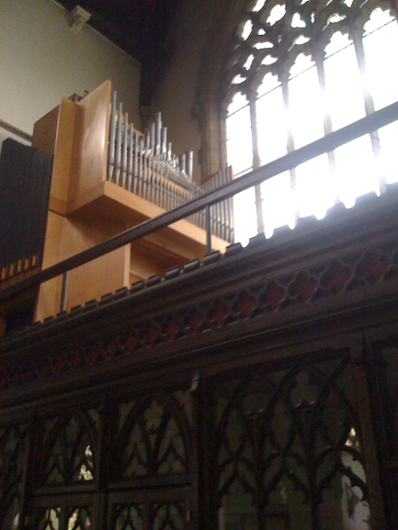
The Chapel-Gallery Organ
A Short History

1. Background
The Downing organ, which was one of the smallest amongst those serving Cambridge college chapels, was built new in 1966 by J.W.Walker & Sons, a respected firm of organbuilders based, at that time, in West London. (Within ten years the company was in new ownership and relocated to Suffolk, where it enjoyed considerable success through the 1980s and 90s).
The design of the Downing organ reflected a degree of the conceptual chaos which had persisted throughout European and American organbuilding from the mid 1950s and would endure for 30 years, reaching a peak around 1970. Rooted in Germany in the 1930s, this ‘Organ Reform Movement’ was a reaction — with hindsight a considerable over-reaction — against the obese and over-indulgent beast that the organ had very commonly become during the last decades of the 19th century and the years that followed. Mechanically complex; tonally unfocused and decadent; and visually the material for Searle cartoons, the organ had become a one-man band — or at least that was the proposition.
The outcome was that most new organs were now slimmed down to the point of anorexia, and their mechanisms which for almost a century had increasingly depended upon pneumatic or electrical means, returned once more to the simple system of all-mechanical rods and levers which had existed prior to that — tracker action, as it is known. This new breed, known as the neo-classical organ, was theoretically inspired by the principles of the 17th and 18th centuries. Leanness replaced obesity, and mechanical complexity gave way to simplicity.
Except that it was usually not that simple. The theory was attractive, but so also was the thought that modern physics could, and must, improve upon the traditional designs and materials. Indeed, the idea of returning to basics may have been an easy one to sell, but given the levels of heating in modern buildings, and the expectation of light key-touch that decades of electrical assistance had instilled, in order to keep the customer happy when the goods arrived there had to be significant developments behind the scenes.
Against this background, where does the Downing chapel organ fit in? As built in 1966, when the melting pot was at its hottest and most turbulent, it had decided eccentricities of design, both in its sound and most particularly in its mechanism. The ‘action’ — the components connecting the keys to the pipes — followed the new philosophy in reverting to direct mechanical linkages in which the organist’s fingers did the work. This is entirely sensible, and indeed desirable, in an instrument of this size, but was negated here by an experimental design in which the well-tried wooden rods and levers were replaced by thin nylon cord —fishing line — running over pulleys. The key-touch felt dreadfully spongy, and could not be maintained in constant regulation from key to key.
The pedal section, though small, was electrically operated, as was also the mechanism that operated the different stops. All of this was familiar ground and gave no trouble
When the organ was inspected in 1980 it was the basic areas of key action and wind supply that were of special concern, and which required major surgery. This was in fact carried out, in 1982, by a firm which had made its name in building organs of this style — Grant, Degens & Bradbeer. The employee principally responsible for the work, the late Kenneth Tickell, later founded his own very successful organ building firm in Northampton.
As is very clear, the tracker action to the two main departments was completely renewed in more conventional style, though the over-all 1966 design did impose some limitations and compromises. The console coupling action, and the electric pedal and stop actions, all remained as before. In the wind supply, the Walker compensators were removed for the manuals, and replaced with new to the much more satisfactory Grant, Degens & Bradbeer design.
At the same time several tonal changes were made, largely reliant upon moving around ranks of pipes that already existed, though three entirely new stops were provided, replacing 1966 pipework. The organ remained essentially the same size, though it lost one ‘stop’ since the original Swell Organ reed stop, named Dulcian, had been available in two halves — the treble and bass drawing separately. A spare blank stopknob remains on the console today, and others were moved around or re-engraved with the revised stoplist.
It must be said that as far as it went this work was satisfactorily executed under difficult circumstances, with the organ still being largely assembled. Thirty years later the organ remains unchanged and, in general terms, still functioning quite well. The stoplists of the 1966 and 1982 (current) arrangement follow below.

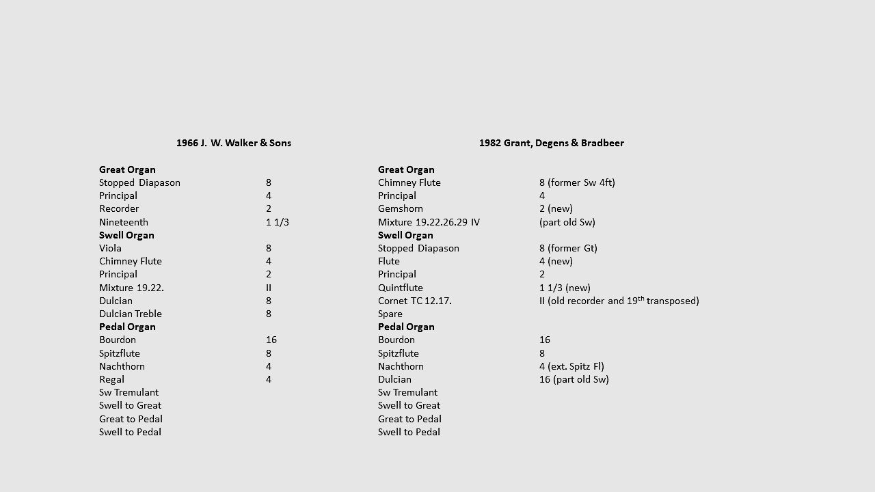

2. Present Condition
Most college or school organs tend to be treated in slightly more cavalier fashion, and therefore wear more quickly, than church instruments — particularly with regard to the console fittings and woodwork. In this case, though, the organ does not seem to have been mistreated and has in general terms worn well. There are short-comings, certainly, but in the near future these are unlikely to become evident to those listening below.
Console: The console is tidily made, to standard dimensions, and remains in fairly good order. The keyboards are of good quality, the playing surfaces being covered in ivory and ebony. The ivory in the middle range has become slightly dished and discoloured but this is of little consequence. There is some side-play from worn bushings, causing irregular gaps between adjacent keys, and the ebony sharps are rather shallow, coming close to the surfaces of the naturals when pressed. The playing surfaces of the pedal keys, and particularly the sharps, are showing some wear and side play, but no more than would be expected. The relationship between the manual keys and the pedal keyboard is set to the modern standard.
The thumb pistons are also in the accepted standard position, and the brass composition pedals and swell pedal are quite conveniently placed. All of this is as one would expect from well-practised firm such as Walker. The stopknobs are of turned hardwood with ivory inserts, and are becoming rather worn and discoloured — entirely as would be expected after 35 years’ handling. The bushings, in white plastic, are loose in some instances, and becoming detached from the oak stop-jambs. There is loose play in the stopknobs and operation of the pistons is quite noisy, but reasonably dependable. It would benefit from a longer built-in ‘hold time’ to give opportunity for the stopknobs to travel the full distance.
Soundboards: Most of the organ’s pipes stand on, or are fed from, the slider soundboards, which supply them individually with wind-pressure according to the combination of keys and stops selected by the organist.
With all of the pipes in place it is impossible to examine the soundboards’ design and condition properly, but these would appear to have plastic sliders, probably running on felt discs. This is the system used on several other Walkers of this period, and although much less sophisticated than more modern designs it allows some tolerance in free movement of the sliders and dissipation of unwanted seepage of wind pressure. The usual tests from the keyboard produced no evidence here of problems with ‘running’ (where a certain amount of wind-pressure seeps from pipes which are being played, to other pipes which should be silent), nor of any other soundboard difficulties.
Off note actions: The pipes for the three Pedal ranks stand on individual actions. Most of these date from 1966 and remain unchanged since that time, apart from the lowest pipes of the Dulcian which are operated by similar actions introduced in 1982 (the smaller notes being on the action provided for the former Regal). All of these are very basic and economical actions, in which the valve or ‘pallet’ under the pipe is attached directly to an electro-magnet. This system is not of high-quality, but it is simple. Unless they become corroded, which can be a result of the action of a humidification plant, these mechanisms are unlikely to give problems; there were no indications of such problems, past or present.
Stop actions: These are working, albeit moderately noisily. They are to an electropneumatic Walker design that can have failings. Principal amongst these is a very narrow margin of tolerance in the power they produce. Here, as a slightly later modification, a second small electric blower has been provided to serve as a booster, and increase the wind-pressure specifically for these machines.
Wind system: The electric blowing plant, consisting of two small blowers of excellent quality, is not giving any cause for concern. A humidifier unit is installed, with a provision of bleed valves to encourage circulation of the humidified air through the wind system, and in particular into the soundboard pallet boxes.
The blower appears adequate and the wind supply is very steady, with little of the pressure-drop under demand which mars some designs.
Pipework: The pipework is of good quality, largely in a 50/50 alloy of lead and tin (“spotted metal”) and is in a good state of repair. Though dusty, it is not positively dirty, nor in need of attention on that account.
Tonally, the organ is unexceptional. There are some pleasant individual stops, but most have a rather neutral and abrupt fluty quality. The Cornet, rebuilt from the former Great Nineteenth and Recorder in 1982, is a particularly good stop, and the unison Flutes are not too bad, albeit very irregular.
Summary: Both mechanically and tonally, the organ betrays its roots in a period of tentative change. It is not, in either respect, a particularly good instrument; neither is it a bad one, and had it been given just a few more resources in 1966 it would have served its College role rather better than it did.

4. Translated to St Mary’s.
The College authorities decided to replace the “old” organ and a new Kenneth Tickell instrument is now (September 2014) in place in the Chapel. Their concern was what to do with the 1966 organ. The removal and breaking-up of the instrument was a real possibility when no home for it could be found. The College did not want to destroy it (it had been funded by benefactors), and was anxious, if possible, to avoid having its “bits” cannibalised as part of an organ builder’s general stock. In about 2011 St. Mary’s was offered a similar small, tracker instrument by a convent in south east London the chapel of which was being demolished – but were cruelly gazumped by the nuns and the chance was lost. The Downing organ was introduced to us by our organ tuner Tarquin Wiggins who had originally intended to install the convent organ. The Downing organ was being offered as a gift to a Parish with whom the College had some connection and was prepared to re-install it, and use it. The relatively modest cost (about £10,000) of doing so could be covered by third party donors and it was agreed that St. Mary’s would take it on. So it was that over the summer and autumn of 2014 the instrument was moved and rebuilt on the west gallery here in NW6. So we now have a neo-classical, mechanical action organ in the gallery (a new one would have cost in excess of £150,000 and would have been out of the question). It is an instrument entirely different from the Bishop Chancel Organ (an “Imperial” monster of the type the gallery organ was supposedly the 1960s antidote); it excels in a different musical genre and whilst it is not big enough to carry a large congregation in such an expansive building, it is likely to prove a welcome addition to the music making at St. Mary’s. As of January 2015 the gallery organ is not quite finished (the stop piston system needs to be reconnected and there remain a few “snagging” items) it made its liturgical debut at the Advent Evening service on 30 November (Advent Sunday) 2014. Ideally, it would have been placed on the gallery – centre stage – but that would have meant access to the gallery via the ladder-stairs would have been compromised (the stairs to the gallery were removed many years ago), so for now it is placed sideways-on but with sufficient room to breathe so that it still speaks boldly into the body of the nave.
It is an instrument with limitations, and was not up to the task of servicing a Cambridge College. Nonetheless, rescued by St. Mary’s it will be a great asset and it remains to be seen just how much regular use can be made of it in this lively, modern Parish.

